

**Faculty Research Database**

User Guide



NazarAl-Wattar

Katherine Shaw

Fahad Alotaibi

Christopher Penepent

**Table of Contents**

Introduction 3

Public User 3

Search by Title 4

Search by Professor 4

Search by Keyword 4

Paper Search Results 4

View Details 4

Faculty Page 5

View Paper Details 5

Faculty User 6

Login 6

Edit Paper 7

Delete Paper 8

Add Paper 9

Add Student – Need a student researcher – Return to Search 10

Admin User 11

Login 11

Add Faculty 12

Edit Faculty 12

Delete Faculty 12

Flowchart of User Actions 15

**Introduction**

Welcome to the Faculty Research Database! In this application, you will be able to view information about faculty members and papers that have been published by the faculty. Students, high schoolers, media representatives, and all other members of the public can search for information in the database. Members of the faculty also have the ability to update their list of papers and maintain a list of student researchers. Admin users maintain the list of faculty users. We hope that you enjoy using this application! We have included diagrams that will help you locate items on the screen. If you see a number in parentheses, such as (1), look for a circled number one on the diagram.

The Main Menu is the first screen you will see.

**We will walk through the procedure to search for information first. Information for faculty users is in the second section and information for admin users is in the third section.**

**All Users (Faculty, Student, Public)**

**Search for Information**

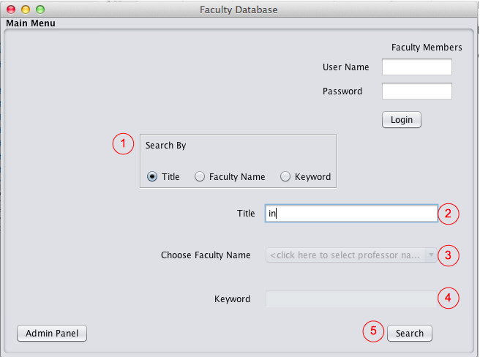

In the Main Menu screen, select one of the radio buttons (1) to search by paper title, faculty member, or keyword.

Both public users and faculty users can use this window to search for faculty information or research papers.

**Search by Title**

To search by title, choose the Title radio button in the Search By section (1) then enter any word(s) contained in the title of the paper you are looking for in the Title text box (2). Then click Search (5) to get the list of papers with titles matching the entered words. Continue to the Paper Search Results section for information about the next screen.

**Search by Professor**

To search by professor, choose the radio button Faculty Name in Search By (1), then select the desired professor name from the drop-down menu (3). Click Search (5) to get the Faculty page for that professor. Continue to the Faculty Page section for information about the next screen.

**Search by Keyword**

To search by keyword, choose the radio button Keyword in Search By (1) then enter the keyword you would like to search for in the Enter Keyword text box (4). Click Search (5) to get the list of papers that contain that keyword. Continue to the Paper Search Results section for information about the next screen.

**Paper Search Results**

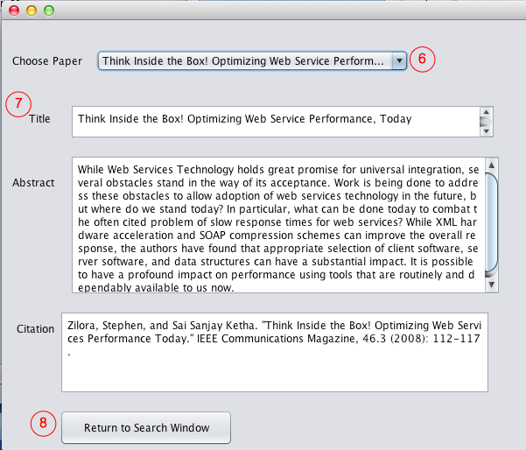

After searching by keyword or title, a list of matching paper titles will display in a drop down menu (6).

Select the title from the drop down list for the paper you wish to see the details and the information will display in the Paper Details section (7).

If you would start a new search, close the window or click Return to Search Window (8) and you can start a new search on the Main Menu.

**Faculty Page**

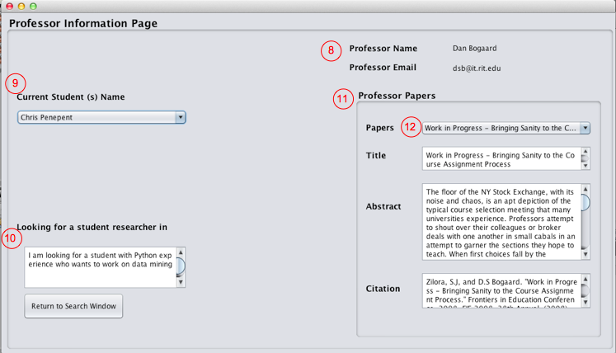

On the Faculty Page, the professor’s name and contact information will display at the top right of the screen (8). Use the professor’s email address to contact that person with requests for research talks or if you are student wanting to work with that professor.

Current students working with the professor are displayed below (9), and if the professor is looking for students to work with him/her then the desired qualifications will be displayed (10).

The papers published by this professor are listed in the papers section (11). To view additional details about a paper, select title from the drop down menu (12). The title, abstract, and citation will be displayed below.

To return to the main menu to see a different professor or paper, close the window or click Return to Search and make new selections in the Main Menu.

**Faculty User**

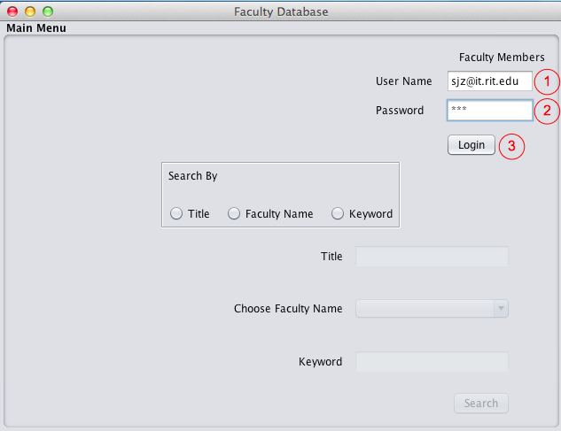

**Logging In**

On the Main Menu screen, the faculty user should provide a username as one of the login requirements. Enter your email address as the username (1). In the Password text box (2), faculty users should provide their password as the second of the login requirements.

After the UserName and Password have been entered, click the Login button (3).

The faculty edit screen will display.

**Faculty Edit Screen**

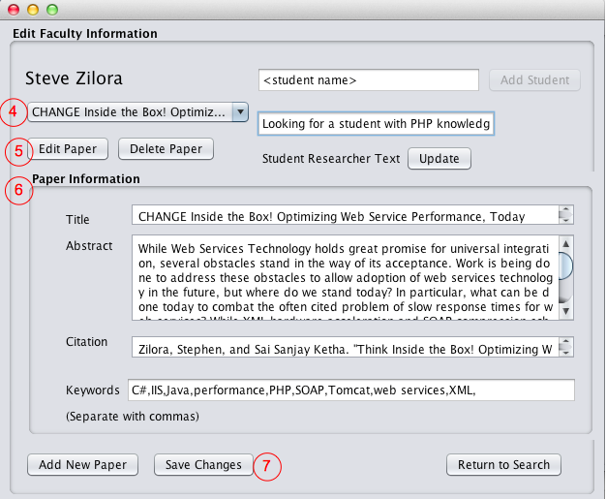

**To Edit a Paper**

Select the paper title from the drop down menu (4), then the paper’s details will be populated in the Paper Information fields (6).

Click Edit Paper (5) to get editable text boxes.

Edit the text in the text fields and make desired changes to Paper Information (Title, Abstract, Citation, and Keywords).

*For the keywords, make sure they are entered separated by commas. For example, “java,computer,c#” if you want to have keywords of java, computer, and c#.

After you are done making changes, click Save Changes (7).

An alert will pop up displaying either “Changes Saved” for a successful edit, or “Changes not saved” if the changes were not saved due to an error.

**To Delete a Paper**

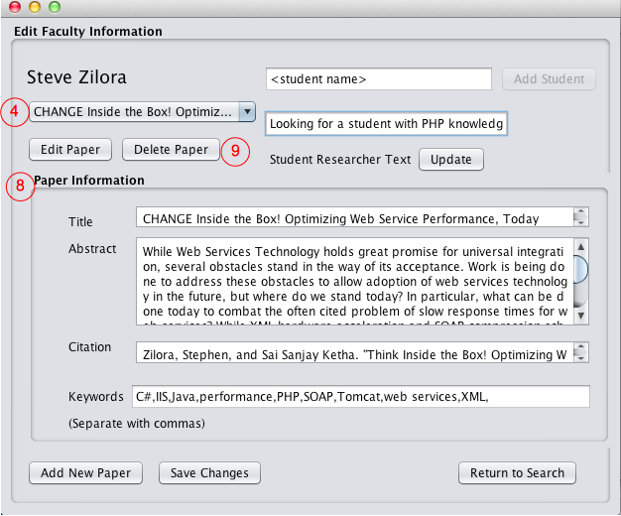

Select the paper title, shown as (4), then the current details will be populated in the Paper Information fields (8).

Click Delete Paper, shown as (9), to delete the paper.

An alert will pop up asking the user to confirm the delete. If you click OK, the paper will be deleted; if you click Cancel, the paper will not be deleted.

**To Add a New Paper**

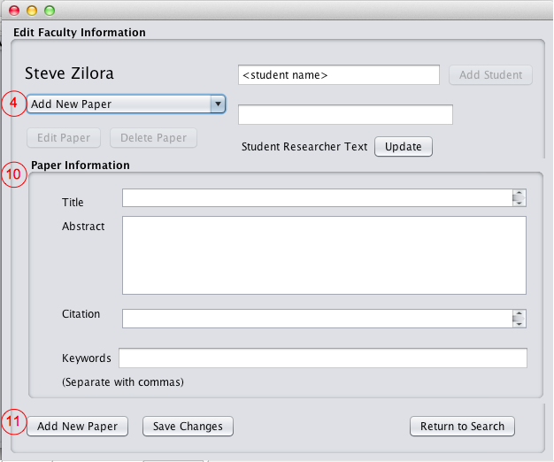Select “Add NewPaper” in the drop-down list (4).

In the Paper Information section (10), enter the details of the paper you would like to add. Enter Title, Abstract, Citation, and Keywords.

*For the keywords, make sure they are entered separated by commas. For example, “java,computer,c#” if you want to have keywords of java, computer, and c#.

Click Add New Paper (11).

An alert will pop up displaying either “Paper Added” if the paper was successfully saved or “Paper Not Saved” if the changes were not saved due to an error.

**To Add a Student**

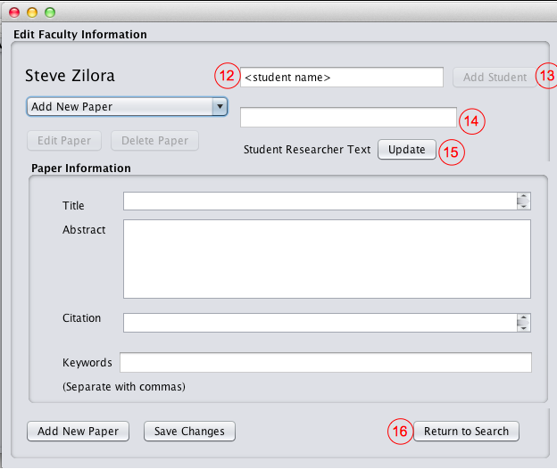You may wish to display the names of the students that are currently working with you on your Faculty Page. To do this, the student’s name must be added.

First, enter the student name in the text box (12).

Then, click Add Student (13).

A confirmation will pop up, displaying either “Student Added” or “Student already exists”.

Now, this student’s name will be displayed on your faculty page.

If you would like to display a message on your Faculty page showing that you are looking for students to work on a project, enter the ‘job posting’ message with the qualifications you are looking for in the student researcher text box (14). Then click Update (15). The message will be displayed on your Faculty page.

If you do not need any students to help right now, clear the text from the student research text box. No message will be displayed on the Faculty screen**.**

**To return to the main screen** to search for paper or faculty details, click the Return to Search button (16).

**Admin User**

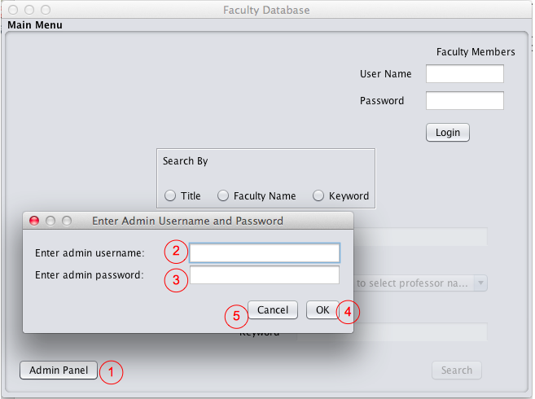

**Logging In**

To access the Admin Panel, admin users first need to login. Click the Admin Panel button (1) to start. Next, enter your username (2) and password (3), then click OK (4). If you clicked the Admin Panel button in error, click Cancel (5) to exit the login process.

After your credentials are verified, you will be taken to the Admin Panel window.

**Admin Panel**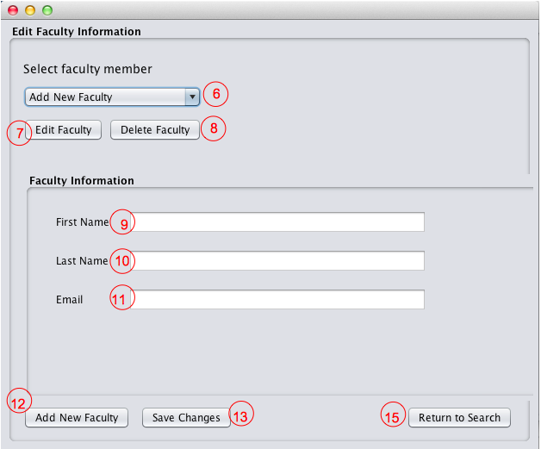

**Add New Faculty**

To add a new faculty member, select Add New Faculty from the drop down list (6). Then enter the faculty details into the First Name (9), Last Name (10), and Email (11) fields. Click the Add New Faculty button (12) to complete the process.

**Edit Faculty**

To edit existing faculty details, select the faculty member name from the drop down list (6). The faculty details will display in the Faculty Information section of the window. Click the Edit Faculty button (7). The First Name (9), Last Name (10), and Email (11) fields are now editable. After you have made the desired changes, click the Save Changes button (13).

**Delete Faculty**

To delete an existing faculty member, select the faculty member name from the drop down list (6). The faculty details will display in the Faculty Information section of the window. Click the Edit Faculty button (8). An alert will ask you to confirm if you want to delete the faculty or cancel.

**Return to Search**

Click the Return to Search button (15) to return to the Main Menu.

**Flowchart of User Actions**

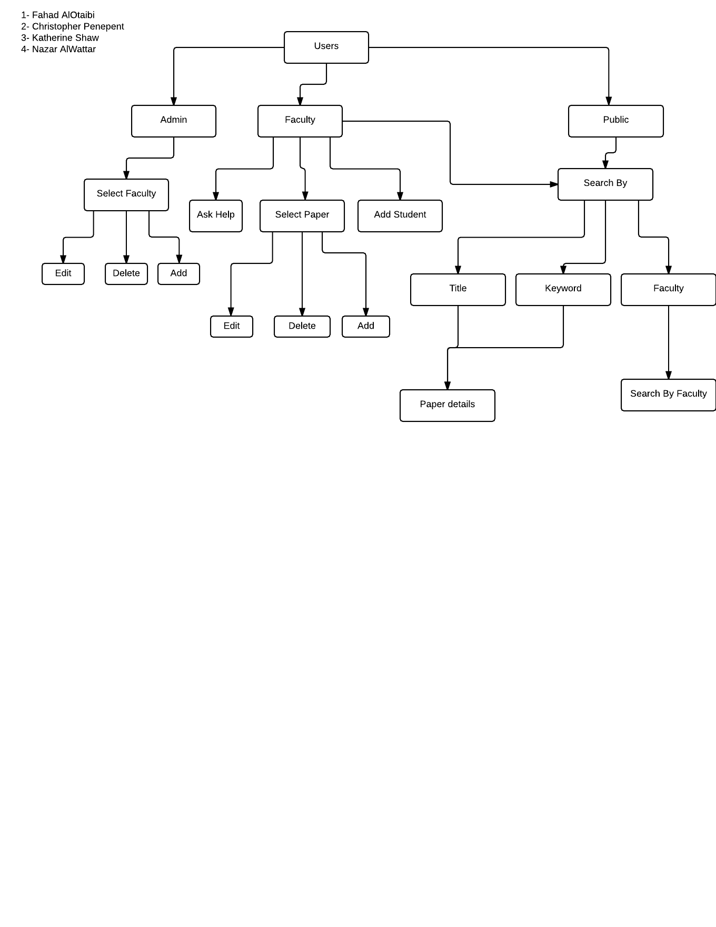For users who prefer a visual path of the application functions, the following diagram shows how different users and actions interact.